JAYPEE INSTITUTE OF INFORMATION
TECHNOLOGY, NOIDA
B. TECH 3 SEMESTER
PROJECT REPORT



CollaboDraw – A Real-Time Collaborative Whiteboard

Submitted to:
Mr. Vicky Gupta

Submitted by:
Pragnya Khandelwal (992401030360)
Pratishtha Singh (992401030361)

Table of Contents
- Introduction
1.1 Project Overview
1.2 Technology Stack
1.3 Problem Statement
1.4 Importance of OOP in the Project
- System Architecture
2.1 Overview of Layered MVC Architecture
2.2 Component Responsibilities
2.3 Data Flow in the Application
- The Four OOP Principles
3.1 Encapsulation
- Definition
- Use in CollaboDraw
- Real-World Analogy
- Benefits
3.2 Inheritance
- Definition
- Controller Inheritance
- Repository Inheritance
- Real-World Analogy
- Benefits
3.3 Polymorphism
- Definition
- Interface Implementations
- Method Overloading
- Real-World Analogy
- Benefits
3.4 Abstraction
- Definition
- Service Layer Abstraction
- Repository Abstraction
- DTO Abstraction
- Benefits
- Layered Architecture in Detail
4.1 Controller Layer (REST API)
4.2 Service Layer (Business Logic)
4.3 Repository Layer (Data Access)
4.4 Model Layer (Entities & DTOs)
- Design Patterns Used
5.1 Repository Pattern
5.2 DTO Pattern
5.3 Singleton Pattern
5.4 Factory Pattern
- Key OOP Benefits in CollaboDraw
6.1 Encapsulation Benefits
6.2 Inheritance Benefits
6.3 Polymorphism Benefits
6.4 Abstraction Benefits
- Real-World Impact
7.1 Development Without OOP
7.2 Development With OOP
7.3 Impact on Maintenance and Scalability
- Conclusion
8.1 Summary of Findings
8.2 Final Thoughts
8.3 Importance of OOP for Real Applications
- UI Screenshots
- References

1. INTRODUCTION
1.1 Project Overview
CollaboDraw is a real-time collaborative whiteboard application developed using the Java Spring Boot framework. It enables multiple users to draw, annotate, and collaborate on digital whiteboards simultaneously, supporting interactive teamwork across distributed environments.
The project demonstrates a production-grade architectural approach grounded in Object-Oriented Programming (OOP) principles. It follows industry-standard best practices such as layered architecture, dependency injection, modular design, and separation of concerns.
Through CollaboDraw, users can create boards, draw graphical elements, and collaborate with others in real time, with all drawing data persisted securely in a relational database.
1.2 Technology Stack
- Backend: Java 17 with Spring Boot 3.5.7
- Database: MySQL 8.0
- Frontend: JavaScript (ES6+), HTML5, CSS3
- Architecture: Layered MVC Pattern
- Build Tool: Maven with Spring Boot Starter Dependencies
- Additional Tools: Spring Data JPA, WebSockets
1.3 Problem Statement
Traditional drawing tools lack the ability to support multiple users collaborating in real-time. These limitations pose challenges for remote teamwork, design brainstorming, and educational collaboration.
CollaboDraw addresses these gaps by providing:
- Multi-user real-time collaboration on shared drawing boards
- Persistent storage of drawings, boards, and user data
- User authentication and access control
- Undo and redo functionality
- Retrieval and replay of drawing history
- Scalable backend capable of handling multiple concurrent users
The aim is to create a professional, extensible application demonstrating how OOP principles improve maintainability, scalability, and modularity.
1.4 Importance of OOP in This Project
OOP principles are essential in building a structured, clean, and scalable application. Without OOP, the system would become monolithic, tightly coupled, and difficult to maintain or extend.
OOP enables CollaboDraw to:
- Break the system into modular components
- Reuse common functionality across layers
- Encapsulate data securely
- Inject interchangeable services
- Test each layer independently
The result is a highly maintainable and professionally structured codebase.

2. SYSTEM ARCHITECTURE
CollaboDraw follows a layered MVC architecture, ensuring a proper separation of concerns. Each layer handles a specific responsibility, enabling modularity and clean dependency flow.
Architecture Flow
User Interface (Frontend)
↓
REST API (Controllers)
↓
Business Logic (Services)
↓
Data Access Layer (Repositories)
↓
Database (MySQL)
Layer Descriptions
- User Interface:
Handles drawing interactions, user actions, and communicates with backend via REST APIs.
- Controller Layer:
Converts HTTP requests into service calls, validates incoming data, and returns API responses.
- Service Layer:
Processes business logic, handles validation, transforms DTOs, and manages transactions.
- Repository Layer:
Abstracts database operations using Spring Data JPA.
- Database Layer:
Stores users, boards, drawing elements, metadata, and history.
3. THE FOUR OOP PRINCIPLES
3.1 Encapsulation
Definition
Encapsulation bundles data and methods inside a class while restricting direct access to internal fields. It ensures controlled modification through public methods.
Usage in CollaboDraw
The Element class represents a drawn shape or line. It encapsulates:
- Position (x, y)
- Color
- Stroke width
- Timestamp
- Associated board ID
Key aspects:
- Fields are private
- Getters and setters manage access
- Validation ensures integrity (e.g., stroke width cannot be negative)
- Complex internal logic remains hidden from external classes
Real-world Analogy
A bank account allows deposits and withdrawals through controlled functions. You cannot directly modify the balance.
Benefits
- Data integrity and security
- Prevents invalid or unsafe operations
- Clear separation between internal state and external usage
- Easier to maintain and debug
3.2 Inheritance
Definition
Inheritance enables classes to inherit properties and methods from parent classes, promoting reuse and hierarchical organization.
Usage in CollaboDraw
Controller Inheritance
All REST controllers inherit from a base class BaseController which provides:
- Unified error handling
- Common logging functionality
- Standardized response formatting
- Shared exception-handling logic
Examples:
DrawingController, BoardController, UserController
Repository Inheritance
Spring Data JPA repositories inherit from:
JpaRepository<Entity, ID>
This provides:
- Save
- Delete
- Update
- Pagination
- Sorting
without writing SQL queries.
Benefits
- Eliminates duplicate code
- Ensures consistency
- Enhances maintainability
- Simplifies creation of new controllers or repositories
3.3 Polymorphism
Definition
Polymorphism allows the same method name or interface to perform different tasks depending on the object invoking it.
Usage in CollaboDraw
Service Interface Implementations
ElementService has multiple implementations:
- DatabaseElementService
Stores drawing data in MySQL.
- CachedElementService
Uses in-memory caching for faster retrieval.
- CloudElementService
Potential extension for cloud-based storage.
All share the same interface but behave differently.
Method Overloading
Example:
save(DrawingElementDTO dto)
save(List<DrawingElementDTO> list)
save(DrawingElementDTO dto, String username)
Same method name, different purposes.
Benefits
- Easily switch implementations
- Extend functionality without rewriting code
- Unit testing becomes straightforward
- Controller remains loosely coupled and independent of specific services

3.4 Abstraction
Definition
Abstraction hides complex implementation details and exposes only essential functions.
Usage in CollaboDraw
Service Layer Abstraction
Developers use simple methods:
save(element);
findByBoardId(id);
deleteElement(id);
Internally, these methods manage:
- Validation
- JSON parsing
- Database operations
- Transaction management
- Caching and error handling
Repository Abstraction
Spring generates SQL queries from method names:
findByBoardIdOrderByCreatedAtAsc(boardId)
No SQL code is written manually.
DTO Abstraction
The API uses DTOs for:
- Clean data transfer
- Avoiding direct exposure of Entity model
- Enforcing API-level validation
Benefits
- Simplifies development
- Shields users from internal complexity
- Improves flexibility when implementations change
- Improves code readability and maintainability

4. LAYERED ARCHITECTURE IN DETAIL
Controller Layer
- Handles HTTP requests
- Maps endpoints
- Validates input
- Converts data to DTOs
- Delegates operations to the service layer
Service Layer
- Implements business rules
- Ensures data consistency
- Acts as a bridge between controllers and repositories
- Utilizes polymorphism and abstraction extensively
Repository Layer
- Extends JpaRepository
- Performs data access operations
- Defines custom query methods
- Encapsulates database interactions
Model Layer
Includes:
- Entity classes
- DTOs
- Mapping logic
Encapsulates data structures and ensures strict typing.

5. DESIGN PATTERNS USED
Repository Pattern
Separates data access from the business layer.
Allows changing the database without affecting core logic.
DTO Pattern
Decouples API data from internal entity representation.
Improves security and prevents overexposure of database structure.
Singleton Pattern
Spring creates singleton instances of:
- Services
- Repositories
- Controllers
Ensures global consistency and optimized memory usage.
Factory Pattern
Spring’s built-in bean factory creates objects and injects dependencies automatically.

6. KEY OOP BENEFITS IN COLLABODRAW
OOP Principle | Implementation Example | Benefit
Encapsulation | Private fields, setters validation | Improved data integrity
Inheritance | Base controllers, JPA inheritance | Reduced code duplication
Polymorphism | Multiple service implementations | Flexible and extensible system
Abstraction | Service layer, DTOs, repositories | Simplified code and maintenance

7. REAL-WORLD IMPACT
Without OOP
- Large, unmanageable codebases
- Tight coupling between components
- Difficult to extend or add new features
- High risk of breaking the system when modifying code
- Slow onboarding for new developers
With OOP
- Organized, modular codebase
- Strong separation of concerns
- Easy addition of new features
- Testable independent components
- Faster debugging and maintenance
- Professional, industry-level design

8. CONCLUSION
CollaboDraw demonstrates the practical importance of Object-Oriented Programming in real-world software development. By applying Encapsulation, Inheritance, Polymorphism, and Abstraction, the application achieves:
- High maintainability
- Scalable architecture
- Code reusability
- Strong separation of concerns
- Easy extensibility
- Improved testability
This project serves as a strong reference for students and developers learning Java, Spring Boot, and OOP-based system design. It showcases how theoretical principles translate directly into professional-quality applications.

9. UI SCREENSHOTS
LOGIN PAGE 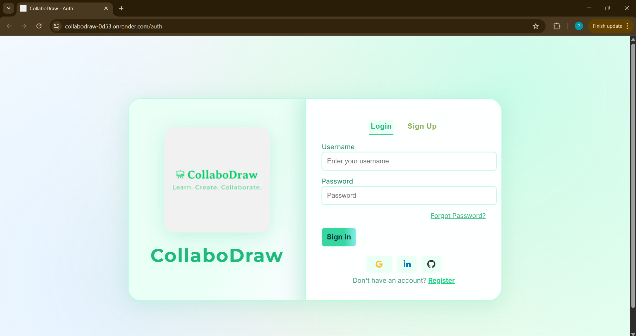
HOMESCREEN 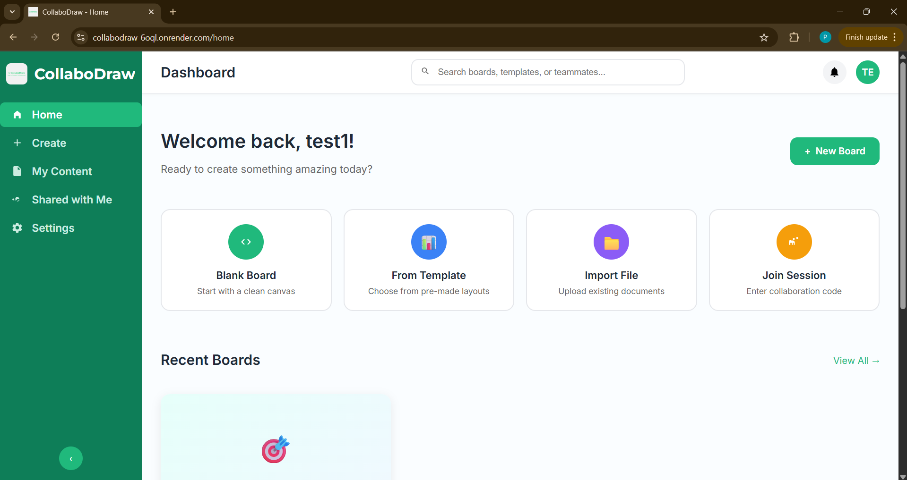
MAIN CANVAS 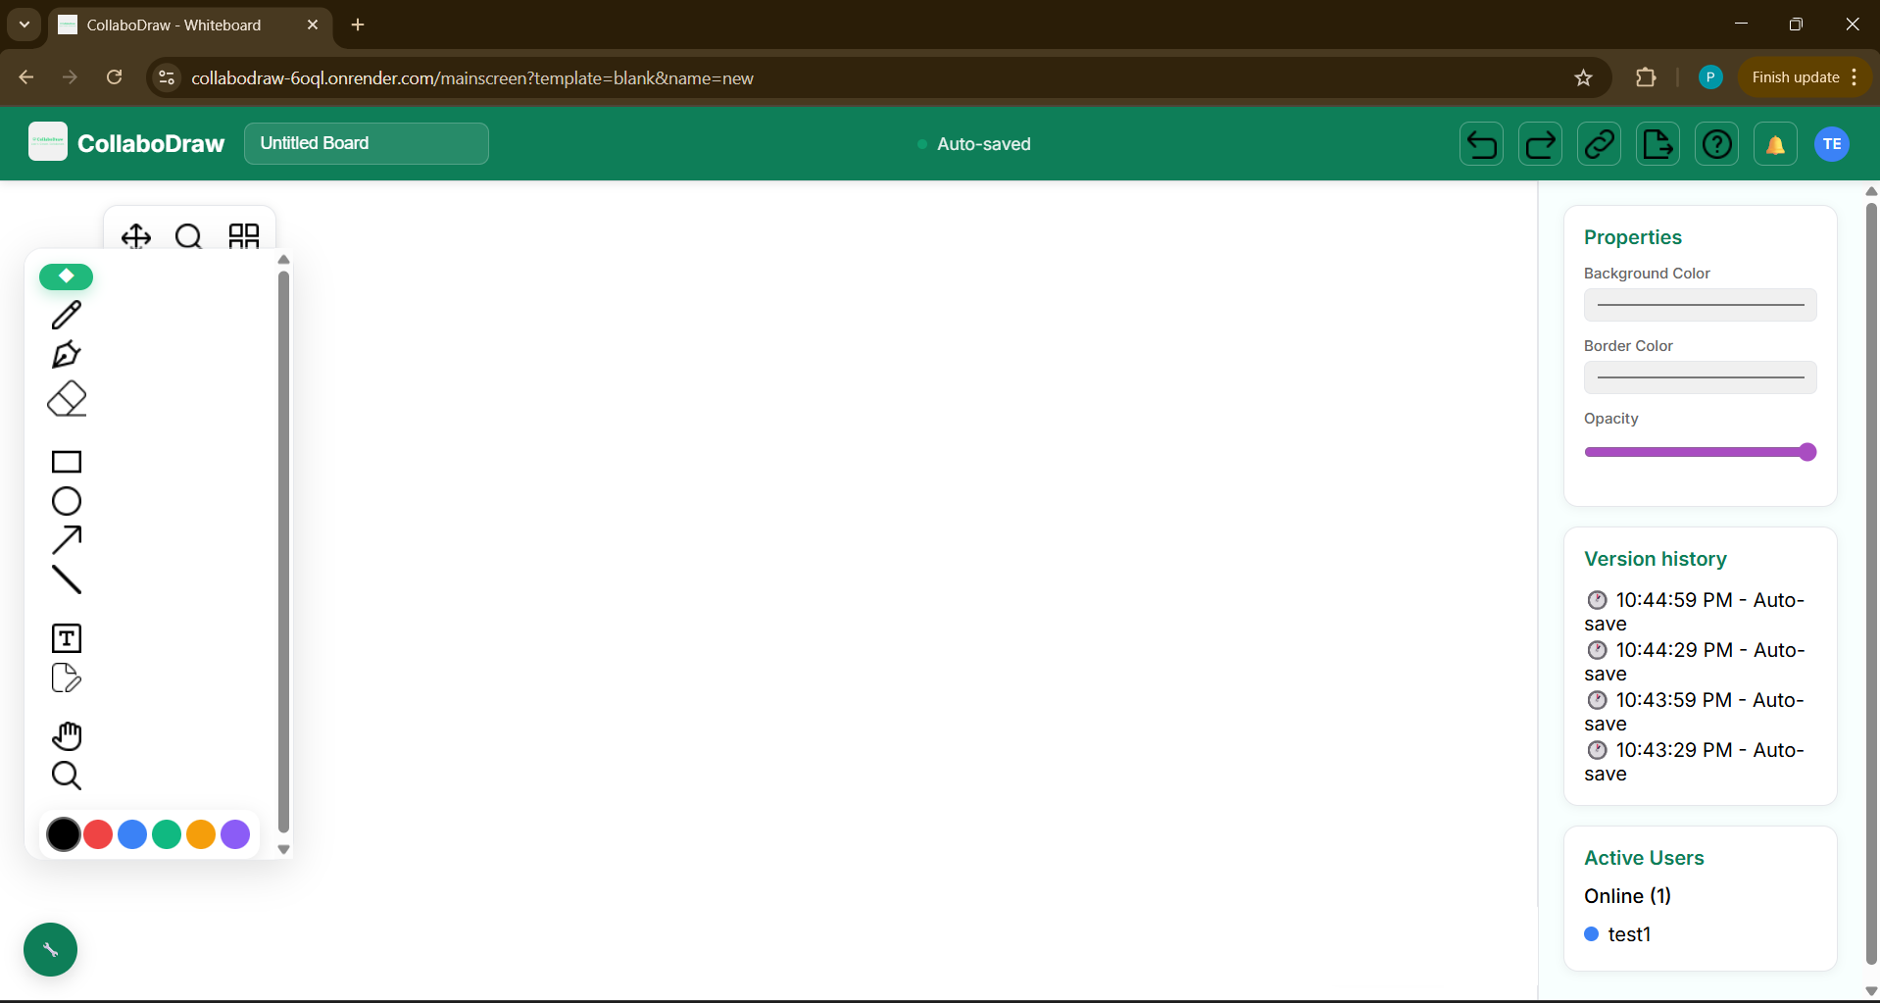
MY-CONTENT PAGE 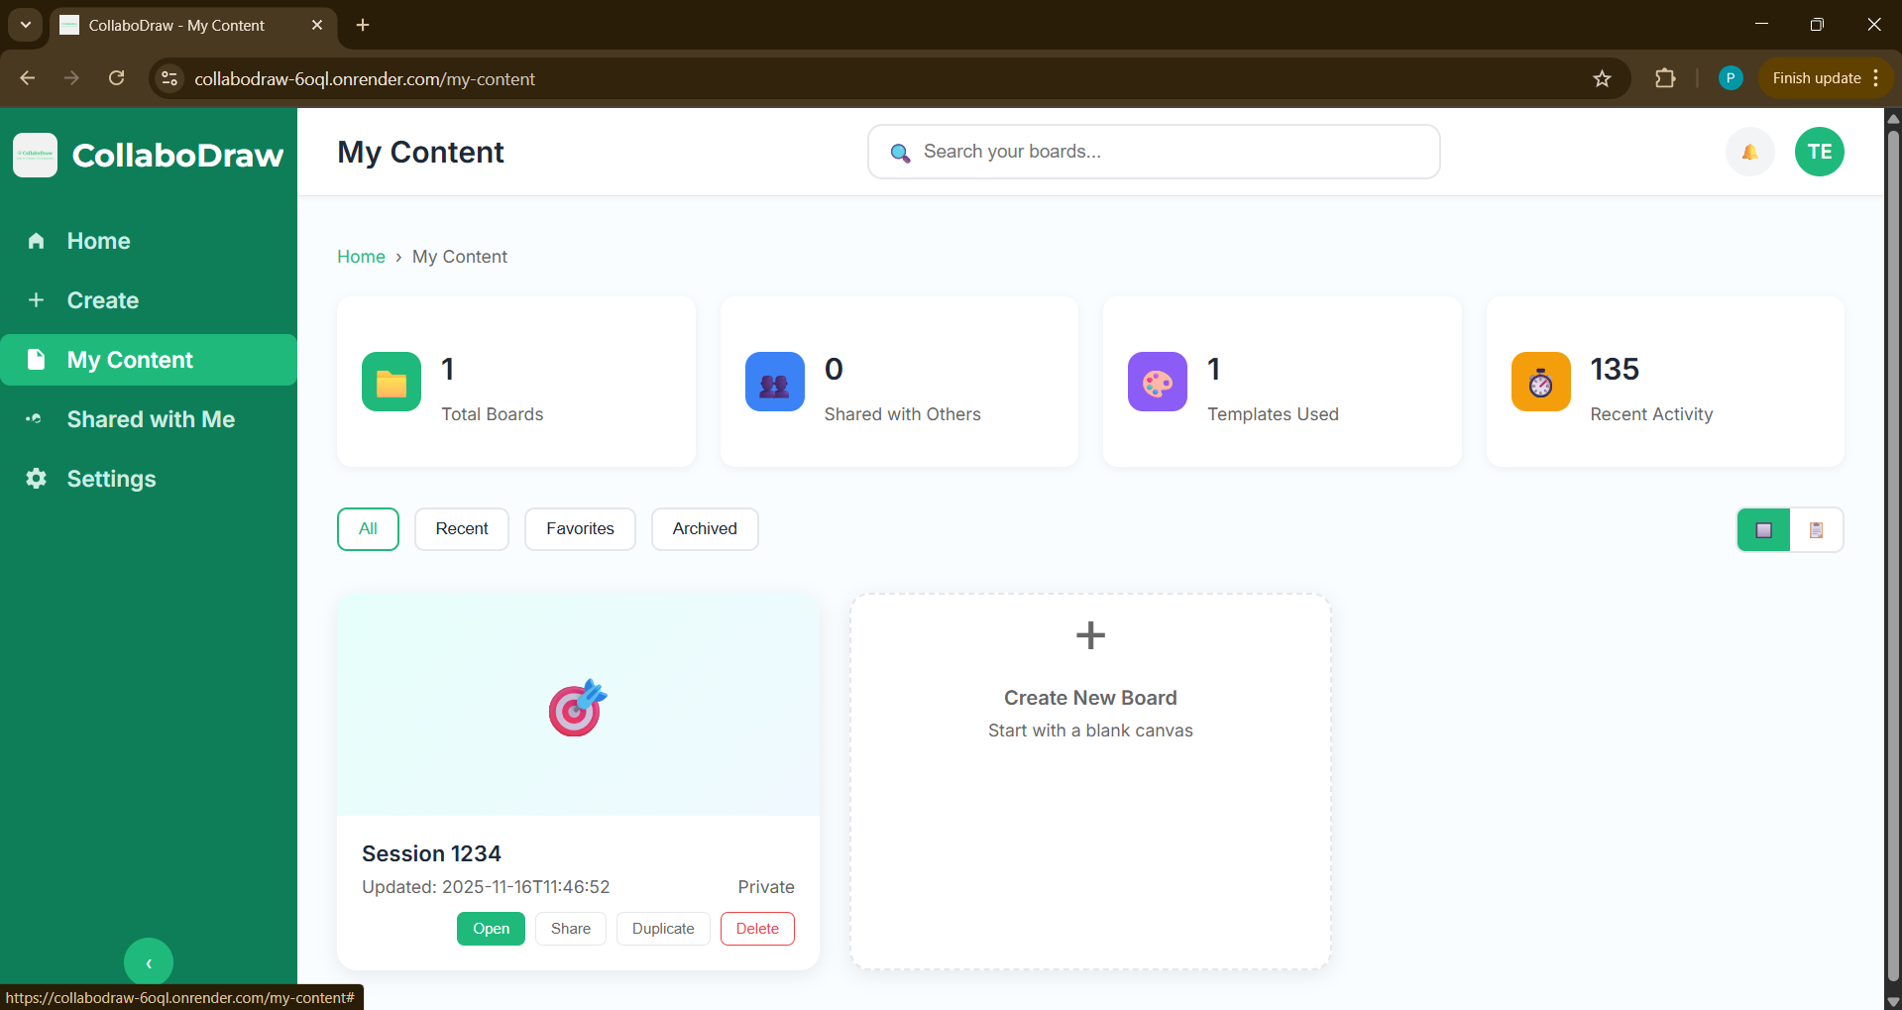
SETTINGS 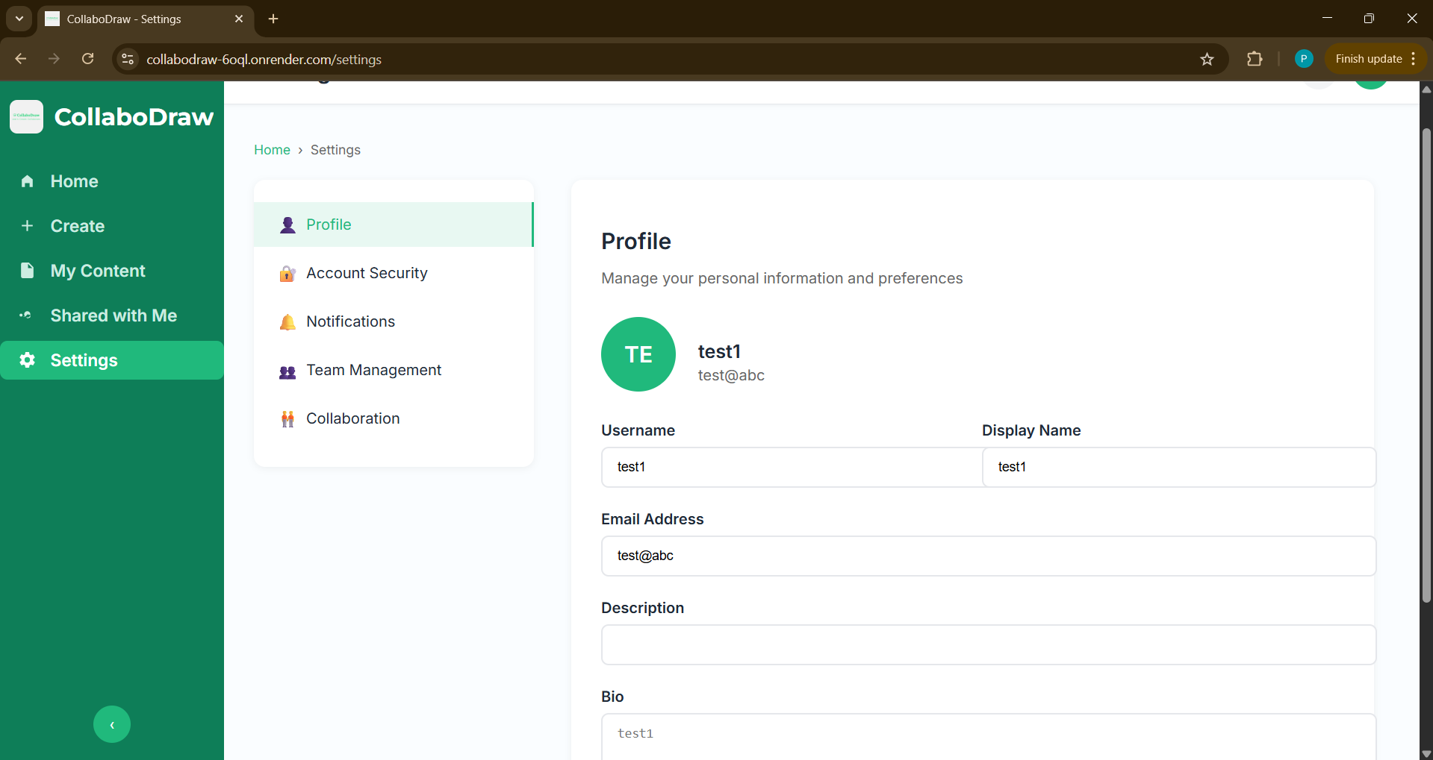
COLLABORATIVE SCREEN 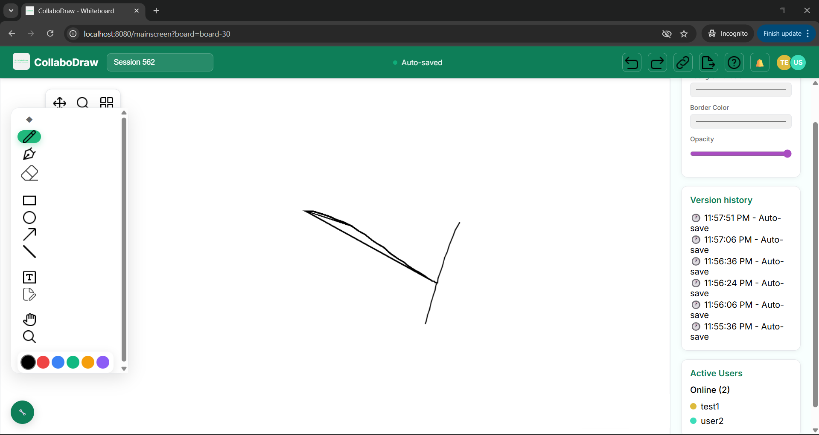

10. REFERENCES
[1] J. Bloch, Effective Java, 3rd ed. Addison-Wesley, 2018.
[2] E. Gamma, R. Helm, R. Johnson, and J. Vlissides, Design Patterns: Elements of Reusable Object-Oriented Software. Addison-Wesley, 1994.
[3] K. Sierra and B. Bates, Head First Java. O’Reilly Media, 2005.
[4] A. Hunt and D. Thomas, The Pragmatic Programmer. Addison-Wesley, 1999.
[5] M. Fowler, Patterns of Enterprise Application Architecture. Addison-Wesley, 2002.
[6] Spring Framework Documentation, “Spring Boot, Spring Data JPA, Spring Web,” 2024. [Online]. Available: https://spring.io/projects/spring-boot
[7] Oracle, “Java Platform, Standard Edition 17 Documentation,” 2024. [Online]. Available: https://docs.oracle.com/en/java/javase/17/
[8] MySQL, “MySQL 8.0 Developer Reference Manual,” 2024. [Online]. Available: https://dev.mysql.com/doc/refman/8.0/en/
[9] R. C. Martin, Clean Code: A Handbook of Agile Software Craftsmanship. Prentice Hall, 2008.
[10] C. Larman, Applying UML and Patterns: An Introduction to Object-Oriented Analysis and Design. Prentice Hall, 2004.
[11] Spring Data JPA Documentation, 2024. [Online]. Available: https://spring.io/projects/spring-data-jpa
[12] E. Freeman, E. Robson, B. Bates, and K. Sierra, Head First Design Patterns. O’Reilly Media, 2004.
[13] E. Evans, Domain-Driven Design: Tackling Complexity in the Heart of Software. Addison-Wesley, 2004.
[14] TutorialsPoint, “Object-Oriented Programming in Java,” 2024. [Online]. Available: https://www.tutorialspoint.com/java/
[15] Baeldung, “Spring Boot and Java Tutorials,” 2024. [Online]. Available: https://www.baeldung.com

